PRAKTIKUM BASIS DATA

MODUL 6
06_Scripting_Subquery

Oleh:

Haryanto Wifakul Azmi 103122400037

PROGRAM STUDI S1 REKAYASA PERANGKAT LUNAK
DIREKTORAT KAMPUS PURWOKERTO
UNIVERSITAS TELKOM
2026
TP

- Tampilkan nama dan umur member yang memesan teater dimana harganya lebih tinggi dari ‘Teater 1’ dan berjudul ‘Habibie AInun 3’! (Gunakan Subquery) (10 Poin)
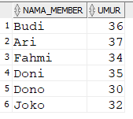
Jawaban:
Query:
SELECT m."NAMA",
TRUNC(MONTHS_BETWEEN(SYSDATE, m."TGL_LAHIR")/12) AS UMUR
FROM "MEMBER" m
JOIN "TRANSAKSI" t ON m."ID_MEMBER" = t."ID_MEMBER"
JOIN "JADWAL" j ON t."ID_JADWAL" = j."ID_JADWAL"
WHERE j."ID_THEATER" IN (
SELECT "ID_THEATER"
FROM "THEATER"
WHERE "HARGA" > (
SELECT "HARGA"
FROM "THEATER"
WHERE "ID_THEATER" = 'Teater 1'
)
)
AND j."ID_FILM" = (
SELECT "ID_FILM"
FROM "FILM"
WHERE "JUDUL" = 'Habibie Ainun 3'
);
Output:
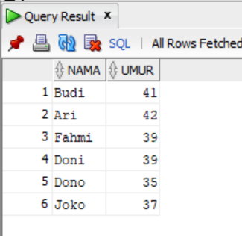
- Tampilkan film yang ditayangkan pada teater paling murah atau paling mahal, urutkan sesuai harga! (Gunakan Subquery) (10 Poin)
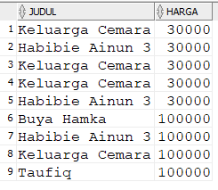
Jawaban:
Query:
SELECT f."JUDUL", th."HARGA"
FROM "JADWAL" j
JOIN "FILM" f ON j."ID_FILM" = f."ID_FILM"
JOIN "THEATER" th ON j."ID_THEATER" = th."ID_THEATER"
WHERE th."HARGA" IN (
(SELECT MIN("HARGA") FROM "THEATER"),
(SELECT MAX("HARGA") FROM "THEATER")
)
ORDER BY th."HARGA";
Output:
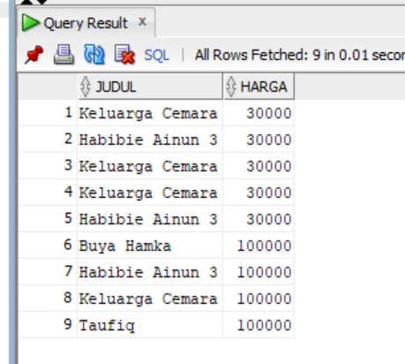

- Tampilkan film yang ditayangkan lebih banyak dari film yang ditayangkan paling sedikit! (Gunakan Subquery) (10 Poin)
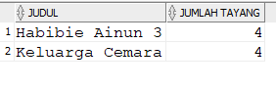
Jawaban:
Query:
SELECT f."JUDUL", COUNT(*) AS JUMLAH_TAYANG
FROM "JADWAL" j
JOIN "FILM" f ON j."ID_FILM" = f."ID_FILM"
GROUP BY f."JUDUL"
HAVING COUNT(*) > (
SELECT MIN(jumlah)
FROM (
SELECT COUNT(*) AS jumlah
FROM "JADWAL"
GROUP BY "ID_FILM"
)
);
Output:
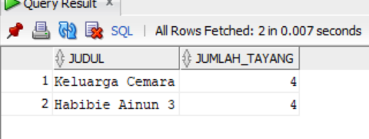

- Tampilkan nomor teater dan film yang ditayangkan melebihi rata-rata penayangan juga berdurasi lebih dari 100! (Gunakan Subquery) (10 Poin)
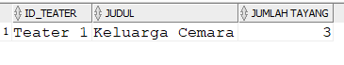
Jawaban:
Query:
SELECT j."ID_THEATER", f."JUDUL", COUNT(*) AS JUMLAH
FROM "JADWAL" j
JOIN "FILM" f ON j."ID_FILM" = f."ID_FILM"
WHERE f."DURASI" > 100
GROUP BY j."ID_THEATER", f."JUDUL"
HAVING COUNT(*) > (
SELECT AVG(jumlah)
FROM (
SELECT COUNT(*) AS jumlah
FROM "JADWAL"
GROUP BY "ID_FILM"
)
);
Output:
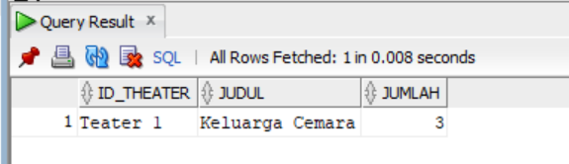
- Tampilkan nama member dan nomor hp beserta film yang ditonton, dimana dia menonton pada teater yang berharga lebih dari ‘30000’ dan member memiliki no hp berawalan ‘081’! (Gunakan Subquery) (10 Poin)
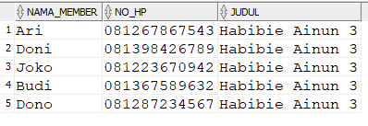
Jawaban:
Query:
SELECT m."NAMA", m."NO_HP", f."JUDUL"
FROM "MEMBER" m
JOIN "TRANSAKSI" t ON m."ID_MEMBER" = t."ID_MEMBER"
JOIN "JADWAL" j ON t."ID_JADWAL" = j."ID_JADWAL"
JOIN "FILM" f ON j."ID_FILM" = f."ID_FILM"
WHERE j."ID_THEATER" IN (
SELECT "ID_THEATER"
FROM "THEATER"
WHERE "HARGA" > 30000
)
AND m."NO_HP" LIKE '081%';
Output:

